5.3.3 Number of sports and cultural events / competitions organized by the institution:
Name of the event/competition | No. of Students Participated
TECHNOTSAV | 3100
Sports League in Cricket | 180
SICET -TRADITIONAL DAY (Rangoli) | 250
SICET -TRADITIONAL DAY (Bathukamma) | 210
SICET -TRADITIONAL DAY (UTTLU BREAKING) | 140
SICET -TRADITIONAL DAY (DHANDIYA) | 210
ANNUAL DAY (RAMP WALK) | 90
ANNUAL DAY (DANCE PROGRAM) | 160
ANNUAL DAY (SINGING PERFORMANCE) | 20
ANNUAL DAY (FANCY DRESS) | 140
MUSIC & DANCE (CULTURAL FEST) | 170
GRADUATION DAY | 560

TECHNOTSAV 2020
Every year we conduct national level technical fest and attract the students all over the country.
• Technotsav is a platform which encourages innovative ideas to promote technology and scientific thinking
• It plays a vital role in student career development.
• Technotsav is known for hosting variety of events that include competitions, exhibitions, lectures as well as workshops.
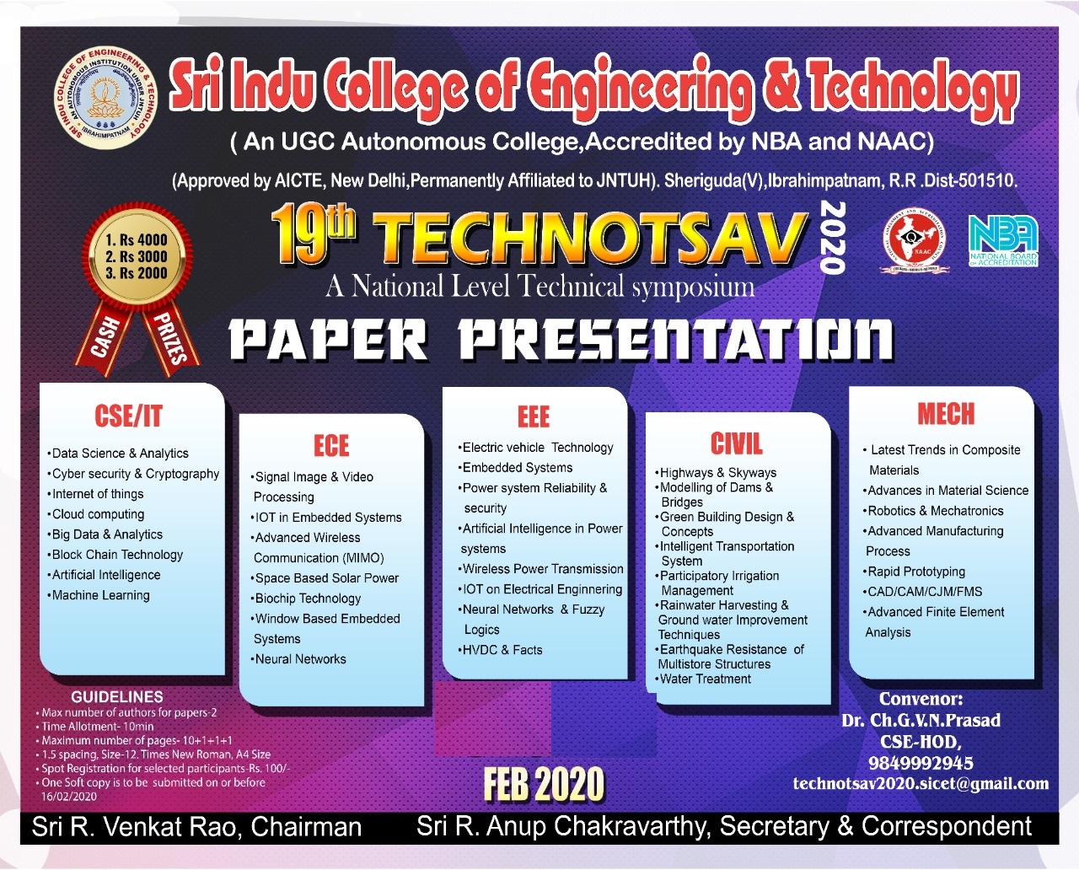

GRADUATION DAY
Every year hundreds of students are graduated with at most pass percentage.
• Students are assured to get placements in MNCs.
• The Graduated students are facilitated amidst the dignitaries, the governing body members, staff and students and with parents.
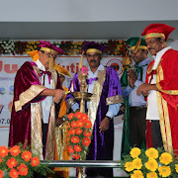
ANNUAL DAY
Annual Day forms an integral part of our college activities.
• It is an occasion of celebration, felicitation, feast and festivity
• Students express not only their wonderful performances but also receive honors for their curricular and co-curricular achievements.
• Annual day is a platform which encourages students to refresh themselves

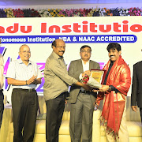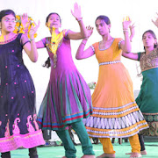

TRADITIONAL DAY
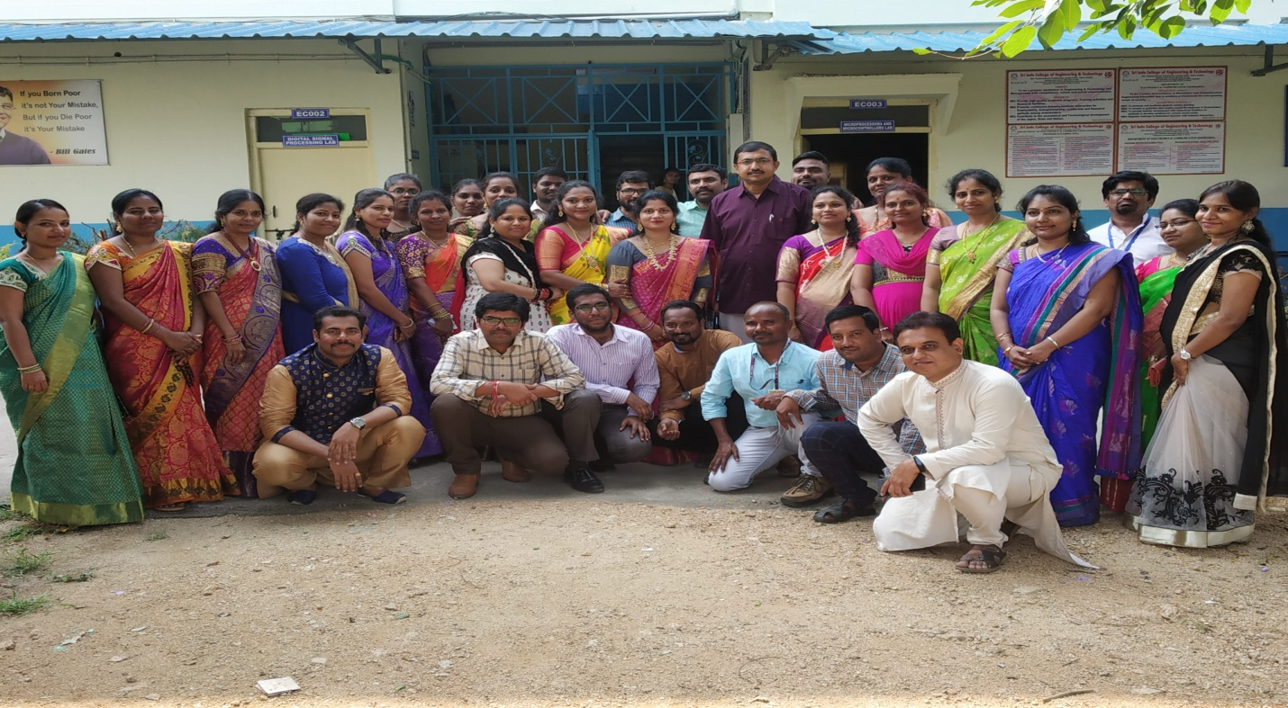
UTTI BEAKING PROGRAM
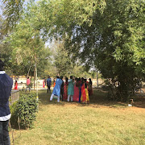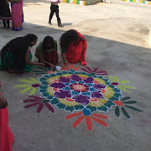

BATHUKAMMA DAY
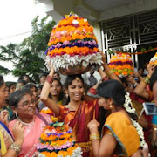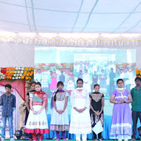

RANGOLI DAY
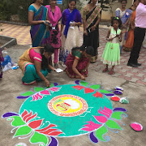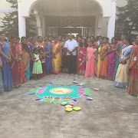

SPORTS DAY
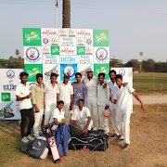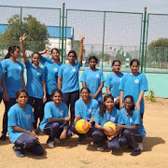

SINGING COMPETITIONS
