About NEW LOYOLA Model Educational Society(NLMES)
The NEW LOYOLA Model Educational Society(NLMES) had taken its birth with the social objective of providing educational opportunities to the rural youth who had been migrating to the towns in pursuit of education. The concept gained momentum and NEW LOYOLA Model Educational Society(NLMES) was established and Registered on 23rd August, 1979 under Societies Act XXI of 1860 with the following objectives, incorporated in the memorandum of articles.
- To establish, aid and maintain educational, cultural and other institutions to impart education, at all stages, for promotion of literature, arts and science and all other subjects for the diffusion of useful knowledge in Andhra Pradesh.
- To raise necessary funds to maintain educational institutions under its management and administer them.
- To grant aid to deserving students for promotion of studies.
- To arrange ‘extension lectures’ in one or more branches of knowledge.
- To print and publish journals or magazines with articles contributing to the growth of knowledge, human understanding and culture.
- To do all such other things as may be conducive to the development or incidental to attain the above objects.
The strength of the Society is that it is not a religious or charitable or social or a family trust. No individual had a controlling interest and the society did not bequeath large endowments that confer managing right or controlling interest on any group or individual. It is purely an educational society to which numerous people, organizations and individuals have donated, only to contribute to the cause of education than for a personal gain or aggrandizement.
The enthusiasm, spirit of service and the pursuit of objectives have been sustained for the last forty years by a succession of members. Power struggles to get hold of the society, crises of management, interference in the administration and dominance of individuals in the society’s affairs were totally absent in its history. General Body Meetings, Most of the Executive Members are unanimously elected. Everyone had the same mission, promoting education, not himself.
Quality of instruction through student-centered teaching, updating the teacher-capability and qualifications, exploiting the student talent, developing personality and citizenship in students are the guiding principles in running the institutions. Seminars, Workshops for teachers/students are regularly held to diffuse knowledge beyond the curriculum.
Financial assistance to the poor and needy students was liberally provided through scholarship endowments.
The educational scenario of the nation has been subjected to swift changes. It may not be an exaggeration to state that every passing day heralds a development, if not an upheaval. In every society, there have been attempts to organize the body of existing knowledge, to perceive the natural and also scientific phenomena not merely with awe and reverence but with inductive and deductive logic, reasoning and experimentation so as to understand various occurrences in an enlightened manner. It is to be noted that technological advancement has always been innovative and explorative. Some men of such mettle who have assimilated the essence of educational philosophy established an educational empire

Sri Indu College of Engineering and Technology is sponsored by the New Loyola Model Education Society, Vanasthalipuram was established in the year 2001. The Society proudly announces that it has firm standing in the field of education for the past 41 Years. The College is located in a serene atmosphere abutting the Hyderabad Nagarjunasagar road, facing main road just 15 Kms from L.B. Nagar. There is a bus facilitiy for every 5 minutes besides college buses.

New Loyola Model Education Society has established many institutions right from KG to PG in the areas of Engineering and non Engineering under the chairmanship of Sri R.Venkat Rao. The College has commitment to impart Quality Education in the field of Engineering. The College offers B.Tech, M.Tech., MBA & MCA courses.

Our Vision is to evolve into a center of excellence in Science and Technology through creative and innovative practices in teaching & learning, towards promotion of academic achievement & research excellence to produce globally accepted, competitive and world class professionals who are psychologically strong and emotionally balanced imbibed with social consciousness and ethical values.

New Loyola Model Education Society had been formed in 1979 with a Vision for future to set up and promote such educational Institutions of excellence that would reorient general, technical and professional education with a holistic approach. Assimilating the advances made in various areas of activity and considering the educational needs of the region, many institutions dealing with various academic disciplines have been started.
Our Schools
- Loyola Model High School  - Loyola Model High School  - Loyola Model High School  - Loyola Model High School  - Loyola Montessori House |  | Vanasthalipuram  Saradha Nagar  NGO’s Colony  Vaidehinagar  Vanasthalipuram

Our other Degree & PG Colleges
- Sri Indu Institute of Engineering & Technology  - Sri Indu College of Education  - Sri Indu P.G. College (M.C.A.)  - Sri Indu Institute of Management  - Sri Indu Institute of Pharmacy |  | Ibrahimpatnam  Vanasthalipuram  Vanasthalipuram  Ibrahimpatnam  Ibrahimpatnam
Expert opinions say that “it is like a modern day Engineering and Technology Gurukul marching towards Global Technology.”

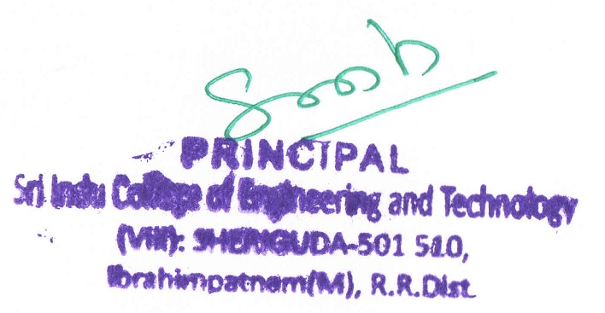

Details of its Management including their Background

Message from Chairman

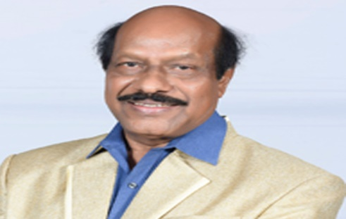
It gives me joy unspeakable to affirm that Sri Indu group of institutions, having completed 39 years successfully, has grown into one of the best institutions in the one of the leading Groups in Hyderabad, Telangana. Our Institute is an Autonomous Institutions under UGC, Recognized under 2(f) and 12(B) of UGC Act 1956, approved by the All India Council of Technical Education (AICTE), NBA Accredited, and NAAC in pipeline and An ISO 9001: 2000 Certified College and Permanently Affiliated to JNTUH.
As everyone is aware of the fact that there is unprecedented advancement in the academic research and industry. Without an iota of doubt, it is to be admitted that the field of engineering and technology has undergone radical changes. That the sound engineering education is synonymous with a better standard of living has become a catchy adage of the day. Besides the acquisition of technical skills, the need of getting oneself familiarized with soft skills like communication skills, organizational skills, crisis management skills, public relations skills, etc., has gained appreciable momentum.
I am quite sure that Sri Indu is not only getting the students prepared for the potential job market but also instilling in them much needed enthusiasm even to work for the nation to meet the social aspirations of our country. I strongly believe that the engineers of today, by their innovation ideas, with their problem-solving attitude and of course, with the humanitarian bent of mind, can establish a better world where people of all nations may live in harmony and peace. By and large, I express my deep sense of commitment for the overall developments of the student community of my institute.

About Chairman
- A dedicated and dynamic personality.
- Pioneer to introduce novel Scholastic methods in the school and the hearts of parents and public.
- He is in Education field since 1979.
- Foresees a “Vision Ahead”. Always struggles to impart better education.
- Awardee by the Govt. of Andhra Pradesh in 1992
- Recipient of “Bharath Jyothi “Award by his excellency, the President of India, Sri Gnani Zail Singh in 1994.
- Chairman of V.V.Info Business Service (India) Ltd., Hyderabad.

Message from Secretary

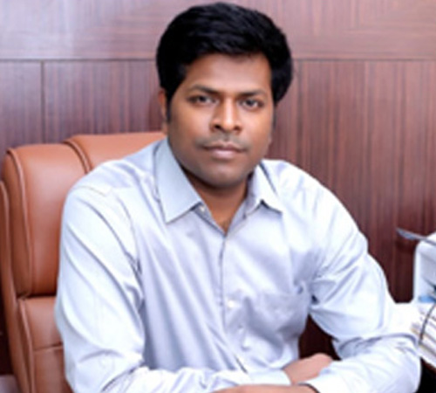
It is my personal observation that the students are perhaps at the most difficult crossroads of their life after their intermediate examinations. The decision they make at this juncture is going to have a long lasting impact on their future life and career. A competent, qualified, experienced and responsible head of the institute can only operate with a vision towards development of an institution.
It is an much instrumental as the engine of train. Our well-equipped laboratories such as laboratories with the computers having high-end configuration, the internet facility, Wi-Fi enabled Campus state of the art library with national and international journals and magazines certainly create a congenial ambience for an ideal engineer in the making to grow.
I am really happy that despite slowdown of economy, Sri Indu has succeeded in bringing various good companies to its campus for placements. All in all, more than 589 students have been placed through campus placements till date during the academic year 2017-18.
Sri Indu Group believes in Bridging Gap between Industry & Research of the students who joined so as to make them apt for facing the challenges of industry and society.
I invite you to join Sri Indu and begin your journey to successful and secured future.

About Secretary

- The present Secretary & Correspondent of the Sri Indu Group of Educational Institutions.
- He is an young and energetic personality.
- Obtained his Masters in Electrical & Electronics Engineering from U.K.
- He has learnt managerial skills from his father Sri.R.Venkat Rao

About TREASURER

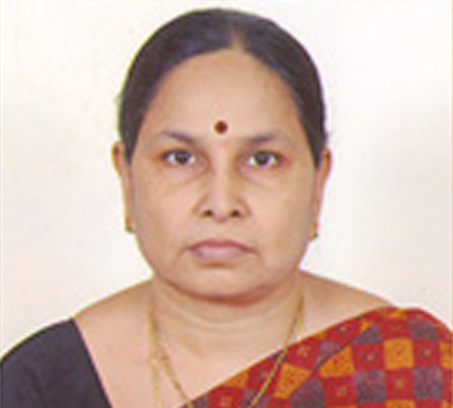 Smt. R. Indumathi TREASURER
- The most dynamic and practical treasurer of the Society.
- She devotes her time for the upliftment of the poor and downtrodden.
- She has Three decades of experience in running the academic institutions.

Our Other Institutions

The NEW LOYOLA Model Educational Society(NLMES) during its 41 years of existence established the following institutions, all known for quality education in their category. The notable feature is that none of the institutions had ever been closed temporarily. There was never an instance when any of the institution had to challenge the action of the statutory bodies or seek redressal of grievances in a court of law.

Our Schools
- Loyola Model High School  - Loyola Model High School  - Loyola Model High School  - Loyola Model High School  - Loyola Montessori House  - Loyola International Schools |  | Vanasthalipuram  Saradha Nagar  NGO’s Colony  Vaidehinagar  Vanasthalipuram  DOHA, DUBAI

Our other Degree & PG Colleges
- Sri Indu Institute of Engineering & Technology  - Sri Indu College of Education  - Sri Indu P.G. College (M.C.A.)  - Sri Indu Institute of Management  - Sri Indu Institute of Pharmacy |  | Ibrahimpatnam  Vanasthalipuram  Vanasthalipuram  Ibrahimpatnam  Ibrahimpatnam
Expert opinions say that “it is like a modern day Engineering and Technology Gurukul marching towards Global Technology.”

VISION AND MISSION OF THE INSTITUTION

VISION

To evolve into a center of excellence in Science and Technology through creative and innovative practices in teaching & learning, towards promotion of academic achievement & research excellence to produce globally accepted, competitive and world class professionals who are psychologically strong and emotionally balanced imbibed with social consciousness and ethical values.

MISSION

To provide high quality academic programmes, training activities, research facilities and opportunities supported by continuous industry – institute interaction aimed at promoting employability, entrepreneurship, leadership and research aptitude among students and contribute to the economic and technological development of the region, state and Nation. To encourage merit of the students by offering Gold Models for Toppers and awarding cash praises for class wise. To develop the Institute into Deemed University.

Quality improvement strategies adopted by the institution to meet Vision and Mision are Curriculum Development

- Required inputs will be taken from various stake holders like companies that visit for placements, experts that visit the college on various occasions, alumni, etc. these inputs are discussed at length in BOS and finalized appropriately.
- A course end survey is conducted at the end of every course and necessary measures are taken. The results of mid exams are mapped with Course Outcomes and the achievement levels are indexed.
- Planned cycles of curriculum review.
- Linking faculty development programs to curriculum design delivery.
- Creating assessment plan and procedures to determine curriculum effectiveness.
- A frame work for optimising local, state and nation standards in curriculum.
- Monitoring curriculum delivery.

Teaching and Learning

- Lesson plan will be prepared in every course and instruction will be delivered adhering to the academic plan. Lesson diary is recorded in the class student attendance register. Instead of listening to the teacher exclusively, students and teachers interact equally.
- Empowering innovation, experimentation and creativity by teachers to effectively utilise new methods of ICTs.
- Designing and conducting bridge courses to help students understand and assimilate institute teaching learning practices.

Research and Development

- Periodical FDPs are organized to encourage in research work.
- Faculty members are encouraged and supported to publish papers and also present papers in conferences and journals with high impact factorthrough incentives like travel reimbursement, funding and awards.
- Modernising laboratories with equipments and tools needed for research and product development.
- Involving students in minor and major research projects.

Library, ICT and physical infrastructure / instrumentation

- The library has a collection of good number of books meeting the requirement of students and faculty. New titles and volumes of text books are added every year continuously, by allocating required budget to procure books and e-journals.
- Information and Communication Technology has been made an integral part of teaching learning process by converting some of the conventional class rooms into e-class rooms. These rooms have been equipped with LCD projectors, digital boards and audio systems.
- Faculty chambers are provided computers with internet facility.

Industry Interaction / Collaboration

The management and departments striv e to enter into MoUs with the industries to provide summer internships & projects Interaction with industry helps to provide industrial visits and research.

