7.1.9 Sensitization of students and employees of the Institution to the constitutional obligations: values, rights, duties and responsibilities of citizens

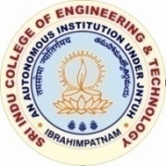

SRI INDU COLLEGE OF ENGINEERING & TECHNOLOGY
(AUTONOMOUS INSTITUTION UNDER UGC, NEW DELHI)
ACCREDITED BY NBA & NAAC
APPROVED BY AICTE, NEW DELHI,
AFFILIATED TO JAWAHARLAL NEHRU TECHNOLOGICAL UNIVERSITY, HYDERABAD
SHERIGUDA(V), IBRAHIMPATNAM(M), R.R.DIST. – 501 510. TELANGANA

Constitutional obligations:
- Constitution of India:
Syllabus
The Constitution of India is the supreme law of India. Parliament of India cannot make any law which violates the Fundamental Rights enumerated under the Part III of the Constitution.
The Parliament of India has been empowered to amend the Constitution under Article 368, however, it cannot use this power to change the “basic structure” of the constitution, which has been ruled and explained by the Supreme Court of India in its historical judgments.
The Constitution of India reflects the idea of “Constitutionalism” – a modern and progressive concept historically developed by the thinkers of “liberalism” – an ideology which has been recognized as one of the most popular political ideology and result of historical struggles against arbitrary use of sovereign power by state.
The historic revolutions in France, England, America and particularly European Renaissance and Reformation movement have resulted into progressive legal reforms in the form of “constitutionalism” in many countries. The Constitution of India was made by borrowing models and principles from many countries including United Kingdom and America.
The Constitution of India is not only a legal document but it also reflects social, political and economic perspectives of the Indian Society. It reflects India’s legacy of “diversity”. It has been said that Indian constitution reflects ideals of its freedom movement; however, few critics have argued that it does not truly incorporate our own ancient legal heritage and cultural values. No law can be “static” and therefore the Constitution of India has also been amended more than one hundred times. These amendments reflect political, social and economic developments since the year 1950.
The Indian judiciary and particularly the Supreme Court of India has played an historic role as the guardian of people. It has been protecting not only basic ideals of the Constitution but also strengthened the same through progressive interpretations of the text of the Constitution.
The judicial activism of the Supreme Court of India and its historic contributions has been recognized throughout the world and it gradually made it “as one of the strongest court in the world”.
Course content
- Meaning of the constitution law and constitutionalism
- Historical perspective of the Constitution of India
- Salient features and characteristics of the Constitution of India
- Scheme of the fundamental rights
- The scheme of the Fundamental Duties and its legal status
- The Directive Principles of State Policy – Its importance and implementation
- Federal structure and distribution of legislative and financial powers between the Union and the States
- Parliamentary Form of Government in India – The constitution powers and status of the President of India
- Amendment of the Constitutional Powers and Procedure
- The historical perspectives of the constitutional amendments in India
- Emergency Provisions: National Emergency, President Rule, Financial Emergency
- Local Self Government – Constitutional Scheme in India
- Scheme of the Fundamental Right to Equality
- Scheme of the Fundamental Right to certain Freedom under Article 19
- Scope of the Right to Life and Personal Liberty under Article 21
- Essence of Indian Traditional Knowledge
Syllabus
Unit I : Introduction to Traditional Knowledge: Define Traditional Knowledge- Nature and Characteristics- Scope and Importance- kinds of Traditional Knowledge- The historical impact of social change on Traditional Knowledge Systems- Value of Traditional knowledge in global economy.
Unit II: Basic structure of Indian Knowledge System: Astadash Vidya- 4 Ved - 4 Upaved (Ayurved,Dhanurved,GandharvaVed&SthapthyaAdi),6vedanga(Shisha,Kalppa,Nirukha,Vykaran,Jyothisha&Chand),4upanga(Dharmashastra,Meemamsa,purana&Tharka Shastra).
Unit III: Modern Science and Indian Knowledge System-Indigenous Knowledge, Characteristics- Yoga and Holistic Health care-cases studies.
Unit IV: Protection of Traditional Knowledge: The need for protecting traditional knowledge - Significance of Traditional knowledge Protection-Role of government to harness Traditional Knowledge.
Unit V: Impact of Traditions: Philosophical Tradition (Sarvadarshan) Nyaya, Vyshepec, Sankhya, Yog, Meemamsa, Vedantha, Chavanka, Jain & Boudh - Indian Artistic Tradition - Chitrakala, Moorthikala, Vasthukala , Sthapthya, Sangeetha, NruthyaYevamSahithya

- Gender Sensitization:
Syllabus
UNIT – I UNDERSTANDING GENDER:
Gender: Why Should We Study It? (Towards a World of Equals: Unit -1) Socialization: Making Women, Making Men (Towards a World of Equals: Unit -2) Introduction. Preparing for Womanhood. Growing up Male. First lessons in Caste. Different Masculinities.

UNIT – II GENDER AND BIOLOGY Missing Women:
Sex Selection and Its Consequences (Towards a World of Equals: Unit-4) Declining Sex Ratio. Demographic Consequences. Gender Spectrum: Beyond the Binary (Towards a World of Equals: Unit -10) Two or Many? Struggles with Discrimination.

UNIT – III GENDER AND LABOUR Housework:
The Invisible Labour (Towards a World of Equals: Unit -3) “My Mother doesn’t Work.” “Share the Load.” Women’s Work: Its Politics and Economics (Towards a World of Equals: Unit -7) Fact and Fiction. Unrecognized and Unaccounted work. Additional Reading: Wages and Conditions of Work.

UNIT – IV ISSUES OF VIOLENCE Sexual Harassment:
Say No! (Towards a World of Equals: Unit -6) Sexual Harassment, not Eve-teasing- Coping with Everyday Harassment- Further Reading: “Chupulu”. Domestic Violence: Speaking Out (Towards a World of Equals: Unit -8) Is Home a Safe Place? -When Women Unite [Film]. Rebuilding Lives. Additional Reading: New Forums for Justice. Thinking about Sexual Violence (Towards a World of Equals: Unit -11) Blaming the Victim-“I Fought for my Life….” – Additional Reading: The Caste Face of Violence.

UNIT – V GENDER : CO – EXISTENCE Just Relationships:
Being Together as Equals (Towards a World of Equals: Unit -12) Mary Kom and Onler. Love and Acid just do not Mix. Love Letters. Mothers and Fathers. Additional Reading: Rosa Parks-The Brave Heart.

- Intellectual Property Rights:
Syllabus
UNIT – I: Introduction to Intellectual property:
Introduction, types of intellectual property, international organizations, agencies and treaties, importance of intellectual property rights.

UNIT – II: Trade Marks:
Purpose and function of trademarks, acquisition of trade mark rights, protectable matter, selecting, and evaluating trade mark, trade mark registration processes.

UNIT – III: Law of copy rights :
Fundamental of copy right law, originality of material, rights of reproduction, rights to perform the work publicly, copy right ownership issues, copy right registration, notice of copy right, international copy right law. Law of patents: Foundation of patent law, patent searching process, ownership rights and transfer

UNIT – IV: Trade Secrets:
Trade secrete law, determination of trade secrete status, liability form is appropriations of trade secrets, protection for submission, trade secrete litigation. Unfair competition: Misappropriation right of publicity, false advertising.

UNIT – V: New development of intellectual property:
New developments in trade mark law; copy right law, patent law, intellectual property audits. International overview on intellectual property, international – trade mark law, copy right law, international patent law, and international development in trade secrets law.

- Professional Practice, Law & Ethics:
Syllabus
Unit – I :Professional Practice – Respective roles of various stakeholders: Government (constituting regulatory bodies and standardization organizations, prescribing norms to ensure safety of the citizens); Standardization Bodies (ex. BIS, IRC)(formulating standards of practice); professional bodies (ex. Institution of Engineers(India), Indian Roads Congress, IIA/ COA, ECI, Local Bodies/ Planning Authorities) (certifying professionals and offering platforms for interaction); Clients/ owners (role governed by contracts); Developers (role governed by regulations such as RERA); Consultants (role governed by bodies such as CEAI); Contractors (role governed by contracts and regulatory Acts and Standards); Manufacturers/ Vendors/ Service agencies (role governed by contracts and regulatory Acts
and Standards)
Professional Ethics – Definition of Ethics, Professional Ethics, Business Ethics, Corporate Ethics, Engineering Ethics, Personal Ethics; Code of Ethics as defined in the website of Institution of Engineers (India); Profession, Professionalism, Professional Responsibility, Professional Ethics; Conflict of Interest, Gift Vs Bribery, Environmental breaches, Negligence, Deficiencies in state-of-the-art; Vigil Mechanism, Whistle blowing, protected disclosures.

Unit – II : General Principles of Contracts Management: Indian Contract Act, 1972 and amendments covering General principles of contracting; Contract Formation & Law; Privacy of contract; Various types of contract and their features; Valid & Voidable Contracts; Prime and sub-contracts; Joint Ventures & Consortium; Complex contract terminology; Tenders, Request For Proposals, Bids & Proposals; Bid Evaluation; Contract Conditions & Specifications; Critical /“Red Flag” conditions; Contract award & Notice To Proceed; Variations & Changes in Contracts; Differing site conditions; Cost escalation; Delays, Suspensions & Terminations; Time extensions & Force Majeure; Delay Analysis; Liquidated damages & Penalties; Insurance & Taxation; Performance and Excusable Non-performance; Contract documentation; Contract Notices; Wrong practices in contracting (Bid shopping, Bid fixing, Cartels); Reverse auction; Case Studies; Build-Own-Operate & variations; Public-Private Partnerships; International Commercial Terms;

Unit – III : Arbitration, Conciliation and ADR (Alternative Dispute Resolution) system: Arbitration – meaning, scope and types – distinction between laws of 1940 and 1996; UNCITRAL model law – Arbitration and expert determination; Extent of judicial intervention; International commercial arbitration; Arbitration agreements – essential and kinds, validity, reference and interim measures by court; Arbitration tribunal – appointment, challenge, jurisdiction of arbitral tribunal, powers, grounds of challenge, procedure and court assistance; Award including Form and content, Grounds for setting aside an award, Enforcement, Appeal and Revision; Enforcement of foreign awards – New York and Geneva Convention Awards; Distinction between conciliation, negotiation, mediation and arbitration, confidentiality, resort to judicial proceedings, costs; Dispute Resolution Boards; Lok Adalats

Unit – IV : Engagement of Labour and Labour & other construction-related Laws: Role of Labour in Civil Engineering; Methods of engaging labour- on rolls, labour sub-contract, piece rate work; Industrial Disputes Act, 1947; Collective bargaining; Industrial Employment (Standing Orders) Act, 1946; Workmen’s Compensation Act, 1923; Building & Other Construction Workers (regulation of employment and conditions of service) Act (1996) and Rules (1998); RERA Act 2017, NBC 2017
Unit – V : Law relating to Intellectual property: Introduction – meaning of intellectual property, main forms of IP, Copyright, Trademarks, Patents and Designs, Secrets; Law relating to Copyright in India including Historical evolution of Copy Rights Act, 1957, Meaning of copyright – computer programs, Ownership of copyrights and assignment, Criteria of infringement, Piracy in Internet – Remedies and procedures in India; Law relating to Patents under Patents Act, 1970 including Concept and historical perspective of patents law in India, Patentable inventions with special reference to biotechnology products, Patent protection for computer programs, Process of obtaining patent – application, examination, opposition and sealing of patents, Patent cooperation treaty and grounds for opposition, Rights and obligations of patentee, Duration of patents – law and policy considerations,
Infringement and related remedies.

ENVIRONMENTAL SCIENCE:
Syllabus
UNIT-I
Ecosystems: Definition, Scope, and Importance of ecosystem. Classification, structure, andfunction of an ecosystem, Food chains, food webs, and ecological pyramids. Flow of energy, Biogeochemical cycles, Bioaccumulation, Biomagnification, ecosystem value, services and carrying capacity, Field visits.
UNIT-II
Natural Resources: Classification of Resources: Living and Non-Living resources, water resources: use and over utilization of surface and ground water, floods and droughts, Dams: benefits and problems. Mineral resources: use and exploitation, environmental effects of extracting and using mineral resources, Land resources: Forest resources, Energy resources: growing energy needs, renewable and non renewable energy sources, use ofalternate energy source, case studies.
UNIT-III
Biodiversity And Biotic Resources: Introduction, Definition, genetic, species and ecosystemdiversity. Value of biodiversity; consumptive use, productive use, social, ethical, aesthetic and optional values. India as a mega diversity nation, Hot spots of biodiversity. Field visit. Threats to biodiversity: habitat loss, poaching of wildlife, man-wildlife conflicts; conservation of biodiversity: In-Situ and Ex-situ conservation. National Biodiversity act.
UNIT-IV
Environmental Pollution and Control Technologies: Environmental Pollution:
Classification of pollution, Air Pollution: Primary and secondary pollutants, Automobile and Industrial pollution, Ambient air quality standards. Water pollution: Sources and types of pollution, drinking water quality standards. Soil Pollution: Sources and types, Impacts of modern agriculture, degradation of soil. Noise Pollution: Sources and Health hazards, standards, Solid waste: Municipal Solid Waste management, composition and characteristics of e-Waste and its management. Pollution control technologies:Wastewater Treatment methods: Primary, secondary and Tertiary.

Overview of air pollution control technologies, Concepts of bioremediation. GlobalEnvironmental Issues and Global Efforts: Climate change and impacts on humanenvironment. Ozone depletion and Ozone depleting substances (ODS). Deforestation and desertification. International conventions / Protocols: Earth summit, Kyoto protocol, and Montréal Protocol. NAPCC-GoI Initiatives.
UNIT-V
Environmental Policy, Legislation & EIA: Environmental Protection act, Legal aspectsAir Act- 1981, Water Act, Forest Act, Wild life Act, Municipal solid waste management and handling rules, biomedical waste management and handling rules, hazardous waste management and handling rules. EIA: EIA structure, methods of baseline data acquisition. Overview on Impacts of air, water, biological and Socio-economical aspects. Strategies for risk assessment, Concepts of Environmental Management Plan (EMP). TowardsSustainable Future: Concept of Sustainable Development Goals, Population and itsexplosion, Crazy Consumerism, Environmental Education, Urban Sprawl, Human health, Environmental Ethics, Concept of Green Building, Ecological Foot Print, Life Cycle assessment (LCA), Low carbon life style.

National Festivals:
Title of Activity: Republic Day
Date &Venue: 26-01-2021, Sicet Main Block.
Description of Event: This occasion was graced by Dr.G. SURESH, The program starts with flag hosting followed by national anthem. Guest delivered a lecture, which emphasizes our constitution.
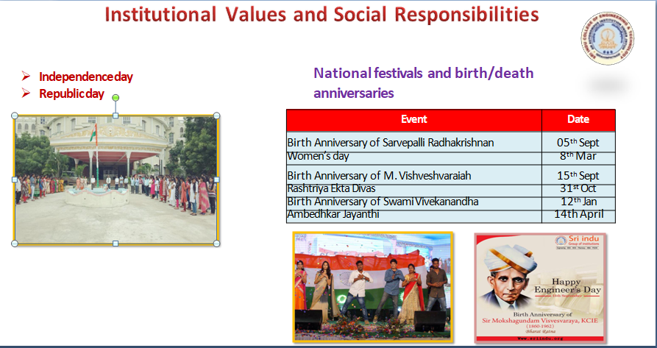

Title of Activity: POLLUTION Day
Date &Venue: 2-12-2020, Sicet R&D Block.

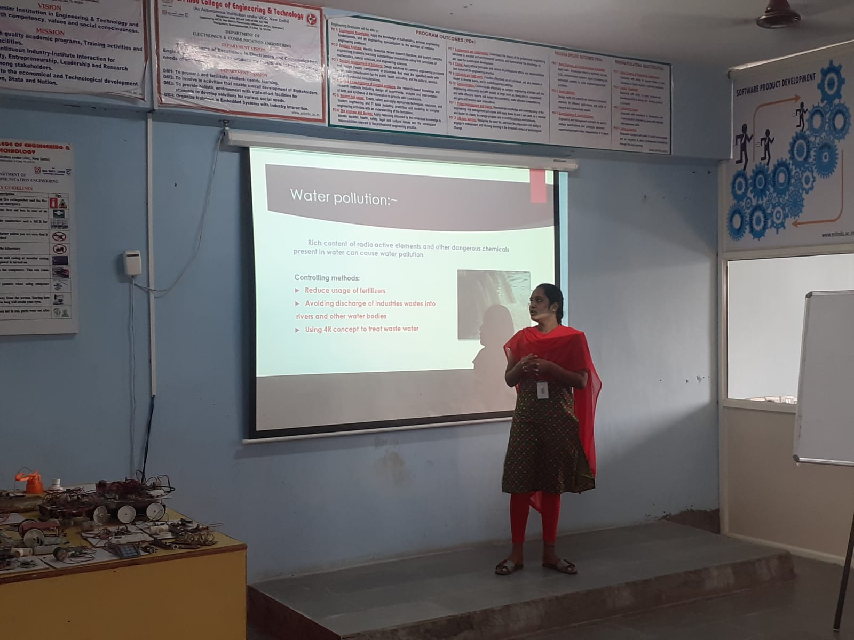

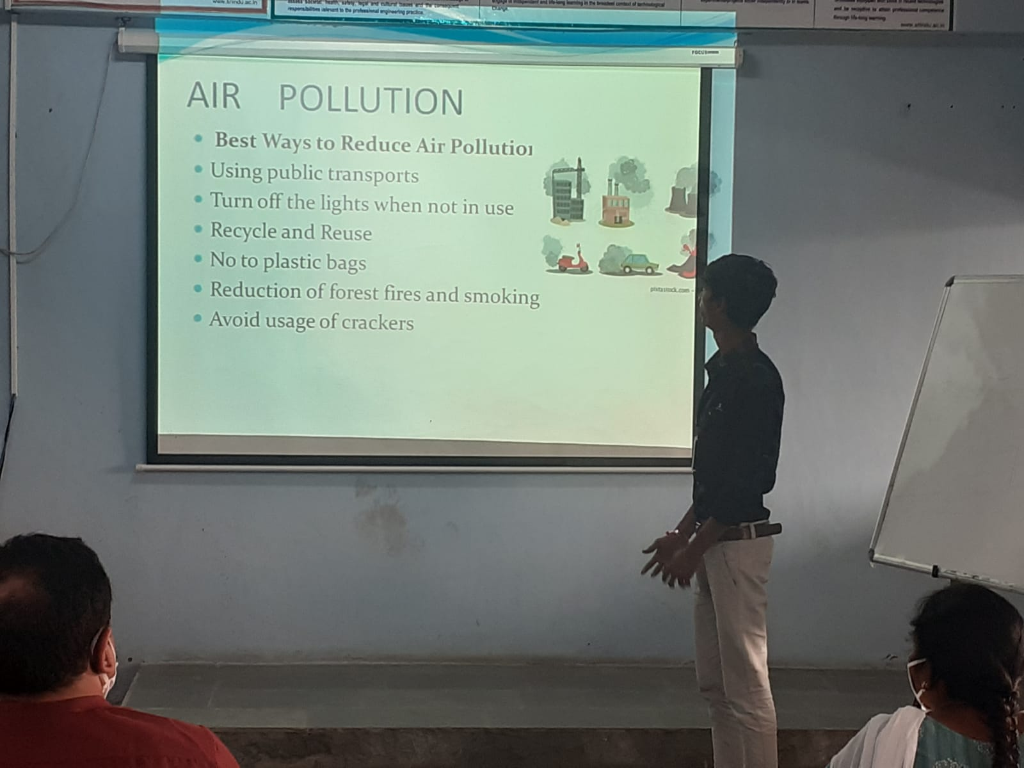

Title of Activity: CONSTITUION Day
Date &Venue: 26-11-2020, Sicet R&D Block.
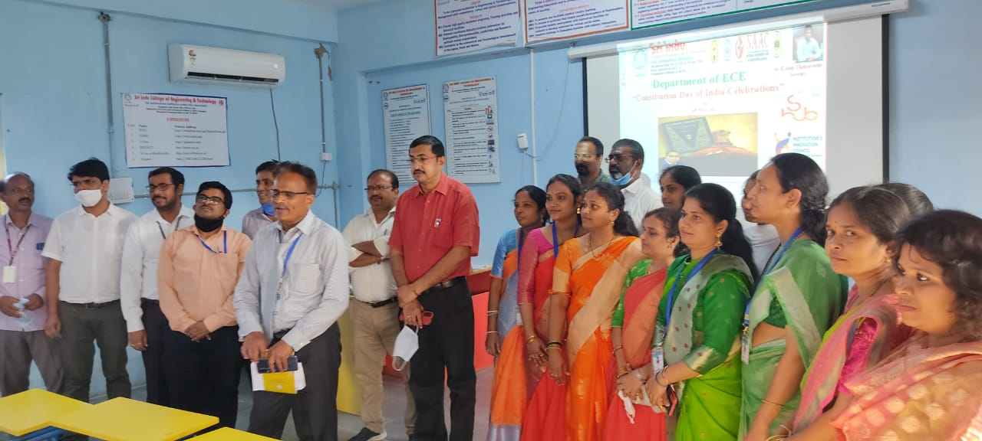
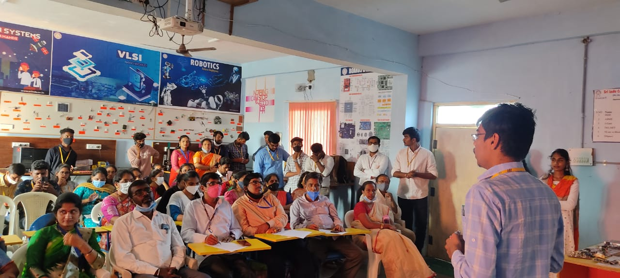

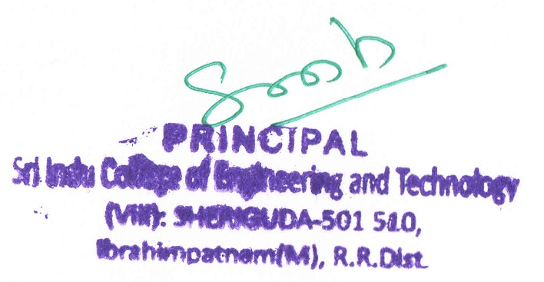

LIST OF ACTIVITIES ORGANIZED
2020-2021
S.NO | Event Name | Department | Event Date | Activity Report
1 | International Yoga Day | NSS | 21.06.2021 | View
2 | Career Guidance for Electrical Engineers | EDC | 26.05.2021 | View
3 | Protecting your Innovations Through Patents | IPR | 22.05.2021 | View
4 | Problem Solving Workshop On 21st Century Skill set | EDC | 18.05.2021 | View
5 | Iris Dataset using KNN Algorithm | ECE | 08.05.2021 | View
6 | One Week Training Program on Skill Development on JAVA | S-HUB & P-HUB | 24.04.2021 to 30.04.2021 | View
7 | Guest Lecture on Segmentation Tree | CSE & IT | 24.04.2021 | View
8 | New Faculty Orientation Program | IQAC | 17.04.2021 | View
9 | Guest Lecture on Face Recognition using Python | CSE | 03.04.2021 | View
10 | How to Start a Career in Machine learning and Artificial Intelligence | R&D Cell | 09.03.2021 | View
11 | Quiz contest on" BUSINESS COMMUNICATION" | EDC | 25.02.2021 | View
12 | Orientation Program On Social Entrepreneurship And Basic Business Plan | SICET IIC | 25.02.2021 | View
13 | Training Session On 100 Shortcuts In Aptitude Skill | TPC | 19.02.2021 | View
14 | Startup Business Idea Development For Innovation & Entrepreneurship | EDC | 10.02.2021 | View
15 | Development Of Entrepreneurship & Innovation Skills | Incubation Cell | 30.01.2021 | View
16 | Workshop on Prototype/ Process Design and Development- Prototyping | IIC | 27.01.2021 | View
17 | Innovative Teaching Strategies | ECE | 25.09.2020 | View
18 | Machine Learning and Python | TASK | 27.08.2020 | View
19 | Internship opportunity in Electrical field | Princeton Smart Engineer | 18.08.2020 | View
20 | Employability Skills | Mahindra Pride Class room | 17.08.2020 & 25.08.2020 | View
21 | IIT Roorkee & Wiley- Post Graduate Certification in AI for BFSI | Miles Education | 14.08.2020 | View
22 | Core jobs in various disciplines of Engineering | HIEE | 12.08.2020 | View
23 | Expectations of the Business Process Management (BPM) Industry Post Covid-19 | TASK | 06.08.2020 | View
24 | Python Programming for Data Science & Machine Learning | 30 Digi TMG | 03.08.2020 to 07.08.2020 | View
25 | Evolving Trends during & Post Covid in Talent Acquisition | WIPRO | 01.08.2020 | View
26 | Free Webinar on Cyber Security | Soebit Cyber security | 01.08.2020 | View
27 | Block Chain Training Program | TASK | 30.07.2020 & 31.07.2020 | View
28 | Think Big | ECE | 22.08.2020 | View
29 | Interview skills | ECE | 21.08.2020 | View
30 | Personal Grooming | ECE | 20.08.2020 | View
31 | Relationship Management | ECE | 19.08.2020 | View
32 | Decision Making | ECE | 18.08.2020 | View
33 | Time and Priority management | ECE | 17.08.2020 | View
34 | Mentorship on Placement awareness and Readiness | ECE | 12.08.2020 | View
35 | Self-Estimation towards Job Scope | ECE | 10.08.2020 | View
36 | Computer Vision and Its Applications | ECE | 25.07.2020 | View
37 | 86.4k | ECE | 30.06.2020 | View
38 | Covid-19 Hackathon | ECE | 08.06.2020  to 28.08.2020 | View
39 | Functional Graded Metal Matrix Composites for Engineering Applications | MECH | 21.05.2020 | View
40 | Advanced Power Technologies | MECH | 20.05.2020 & 21.05.2020 | View
41 | Cyber Security | CSE | 16.05.2020 | View
42 | Digital Productivity | CSE | 15.05.2020 | View
43 | Faculty Awareness Program on Accreditation and Outcome Based Education | IT | 18.05.2020 | View
44 | Face Mask Detector with open CV, Tensor Flow and Deep Learning | IT | 27.05.2020 | View
45 | Innovation And Entrepreneurial Needs In 21st Century | MBA | 21.05.2020 | View
46 | Students Development Programme on Tunnel Technology | CIVIL | 29.05.2020 | View
47 | FDP on SOLAR ENERGY | CIVIL | 19.05.2020 | View
48 | Transformation in Crisis | EEE | 25.05.2020 | View
49 | Prime Time | ECE | 26.06.2020 | View
50 | Deep learning for Radar Imaging | ECE | 30.05.2020 | View
51 | Recent Trends in Electrical Engineering and Renewable Energy Sources | EEE | 23.05.2020 | View
52 | Skill Development Programme on“MATLAB PROGRAMMING” | EEE | 23.05.2020 | View
53 | Skill Development Programme on “PYTHON PROGRAMMING” | ECE | 21.05.2020 | View
54 | Introduction to IOT and its Applications | ECE | 18.05.2020 | View
55 | How to Become A Software Engineer in IT Industry | ECE | 26.05.2020 | View
56 | Real Time Implementation of AIIncorporated With Image Segmentation And Retrieval Process | ECE | 21.05.2020 | View

